

**PRESS RELEASE** Prague, 20 August 2018

**Summer evenings with the Kinobus in BB Centrum**

**For four evenings at the beginning of August, BB Centrum was the stop for the travelling summer cinema, the Kinobus. The warm summer weather and the selection of films attracted an audience of more than a hundred people each evening to watch one of the films being screened free of charge, or even all four. The program featured the action comedy *Spy*, the sci-fi film about the possible future of humanity *Downsizing*, the road movie *The Interpreter* and the domestic comedy *The Tiger Theory*.**

PASSERINVEST GROUP, together with the Prague Public Transit Company, prepared screenings of the Kinobus summer cinema in Prague 4 for cinephiles. Thus, film fans or simple passers-by could enjoy the summer cinema just a short way from their residences or workplaces. And there certainly are a lot of lovers of the silver screen in Prague 4! Each evening the benches were almost overflowing with the number of filmgoers and the film refreshments were also very popular.

This is far from the only cultural/leisure program in BB Centrum and, thanks to the newly-opened Brumlovka Square, the inhabitants of Prague 4 and the wider area can look forward to more interesting events. You can find information on what is currently going on in BB Centrum [here](https://www.facebook.com/BB-Centrum-730141167045202/).

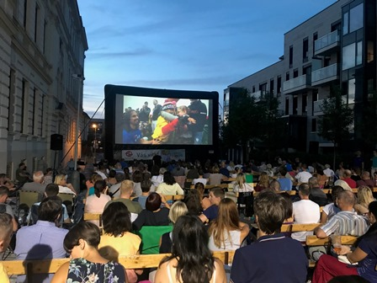

The Kinobus screened hit films in BB Centrum over the course of four evenings

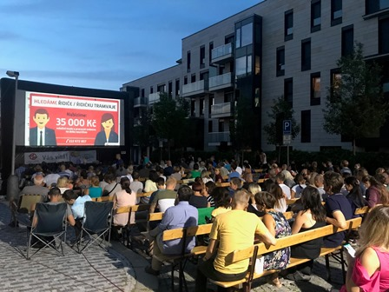

Kinobus in BB Centrum

You can get more information and photographs in print quality from:

Kristýna Samková**,** Head of PR and Marketing dept.

**PASSERINVEST GROUP, a.s.**

Tel.: (+420) 221 582 111

Mobile: (+420) 602 186 708

E-mail: [Kristyna.Samkova@Passerinvest.cz](mailto:Kristyna.Samkova@Passerinvest.cz)

www.passerinvest.cz, [www.bbcentrum.cz](http://www.bbcentrum.cz)

Marcela Štefcová

**Crest Communications a.s.**

Mobile: (+420) 731 613 669

E-mail: marcela.stefcova@crestcom.cz

**About the developer**

**PASSERINVEST GROUP**, a. s., is a purely Czech development and investment company, whose name is primarily connected with the realisation of the multifunctional **BB Centrum** complex in Prague 4 – Michle. The company, established by Radim Passer in 1991, built a very good reputation both on a local and international level with this, the most successful and extensive project of its kind in Central Europe. This is not only to the credit of the quality of the realised projects and the high level of the provided services, but also due to the sense of fair play, an accommodating relationship to the buildings’ tenants/users and responsibility to the society and the environment. **PASSERINVEST GROUP** also has other interesting development projects in its portfolio.